

GUIDELINES FOR LICENSING OF PUBLIC AND PRIVATE MANUFACTURERS, DISTRIBUTORS, WHOLESALERS AND RETAILERS OF HUMAN MEDICINES.

DECEMBER, 2025

FOREWORD

Rwanda Food and Drugs Authority, hereinafter abbreviated as Rwanda FDA, is a regulatory body established by Law N° 003/2018 of 09/02/2018. One of the functions of Rwanda FDA is to formulate and enforce regulations and guidelines for regulating the manufacture, import and export, distribution, sale and use of regulated products under the Law stated above.

Pursuant to the provisions of the Regulations DD/PIL/TRG/001, Governing Licensing of public and private manufacturers, distributors, wholesalers and retailers of medical products, Rwanda FDA issues Guidelines N° DD/PIL/GDL/005 Rev_5 for licensing of public and private manufacturers, distributors, wholesalers and retailers of human medicines.

These Guidelines provide guidance to applicants to make sure that they comply with the prescribed requirements. Applicants are required to familiarize and comply with the Guidelines when preparing and submitting applications for licensing of their premises dealing with manufacture, distribution, wholesale and retail of human medicines.

Adherence to these guidelines will ensure that all relevant information is provided for licensing of premises. This will facilitate efficient and effective analysis of the applications and speed up the approval processes, aimed at protecting the consumers of the products.

Rwanda FDA acknowledges all the efforts of stakeholders who participated in the development and validation of these guidelines.

Prof. Emile BIENVENU
Director General

Document DEVELOPMENT HISTORY

First issue date | 30/08/2020
Effective date of this version | Refer to the Approval Date

DOCUMENT REVISION HISTORY
Revision number | Changes made and/or reasons for revision
1 | - Chapter II is renamed LICENSING & INSPECTIONS instead of Licensing Requirements  Application forms, Formats of w license, Format of notification letter for withdrawal of premises license / Certificate and requirements for application for renewal of the premises license are included
2 | - The timeline for standards of service delivery has been added.  - Description of different sections of the inspection report has been added.  - Revision of requirements to obtain a premises license.  - The title is renamed as Guidelines Governing Licensing of public and private Manufacturers, Distributors, Wholesalers and Retailers of Medical Products instead of Guidelines for Licensing to Manufacture, to Operate as Wholesale and Retail Seller of Medical Products.  - Categorization of inspection findings has been added.  The application form was revised to be used for all categories of premises to replace the former application forms by category.
3 | - Amendment of space requirements of premises of medical products: Private and public Wholesalers, Retailers, Orthopedic and optical shops, health Centre and health posts.  - Clarification on the validity of the premises license for renewal and other variations.  - The Annex I: Process flow chart was revised.  - The Annex III: Premises registration certificate was added.  - The Annex VI: was revised.  Editorial changes to align with the new format.
4 | - Review and/or adding of definition: substantial modification.  - Review of the types of inspection (Based on WHO guidelines)  - Review the licensing requirements of the manufacturer of medical products.  - Minimum requirements for magisterial preparation in the human retail pharmacies have been added.  - The responsibilities of authorized personnel in manufacturing facilities have been added.  The definition of authorized personnel for manufacturer, wholesale and retail of medical products have been added.
5 | - Updated the requirements for distributor and wholesaler  - Updated the checklist  - Categorization of inspection findings were updated  - The process flowchart was updated  - Updated the premises of distributors, wholesalers and retailers of human medicines  - Updated the requirements for premises registration and licensing  - Updated the requirements to re-grant a license or approval of a substantial modification  - Added the licensing of public private partnership (PPP) hospital pharmacy  - Amendment of requirements for licensing the medical storage facilities  - Amendment of validity of an application and authorization  - Defining scope of authorized pharmaceutical products and prohibited products

TABLE OF CONTENTS

FOREWORD 2
Document DEVELOPMENT HISTORY 3
DOCUMENT REVISION HISTORY 3
TABLE OF CONTENTS 5
ACRONYMS AND ABBREVIATIONS 7
GLOSSARY / DEFINITIONS 8
INTRODUCTION 11
SCOPE 11
1. LICENSING AND INSPECTIONS 11
1.1 General requirements for application of registration certificate and premises license 11
1.2 Inspections 12
1.2.1 Types of inspections 12
1.2.2 Approval of the premises 13
1.3 MEDICAL PRODUCTS MANUFACTURING FACILITY 13
1.3.1 Personnel 14
1.3.2 Training 15
1.3.3 Equipment 15
1.4 PREMISES OF DISTRIBUTORS, WHOLESALERS AND RETAILERS OF HUMAN MEDICINES 15
1.4.1 Premises 15
1.4.2 Personnel 20
1.4.3 Training 22
1.4.4 Equipment 22
1.4.5 Documentation and related controls 23
1.5 REQUIREMENTS FOR PREMISES REGISTRATION AND LICENSING 23
1.5.1 Requirements for manufacturer of human medicine 23
1.5.2 Requirements for distributor of human medicines 24
1.5.3 Requirements for wholesaler of human medicines 25
1.5.4 Requirements for licensing the medical storage facilities 26
1.5.5 Requirements to open a human retail pharmacy 27
1.5.6 Requirements to open an online Pharmacy 28
1.5.7 Requirements for Licensing hospital pharmacies 29
1.5.8 Requirements for Licensing Public private partnership (PPP) Hospital Pharmacy 30
1.5.9 Requirements for assistant technician 31
1.6 REQUIREMENTS TO RE-GRANT A LICENSE OR APPROVAL OF A SUBSTANTIAL MODIFICATION 31
1.6.1 Requirements for relocation or additional storage space of the licensed premises 31
1.6.2 Requirements to change the authorized person of the licensed premises 32
1.6.3 Requirements to change the name of the establishment 32
1.6.4 Requirements to change the ownership of the licensed premises 32
1.6.5 Requirements to change the Company Code of the licensed premises 33
1.6.6 Requirements to close the licensed establishment 33
1.6.7 Requirements for renewal of the premises license 33
1.6.8 Requirements for re-inspection of the premises license 34
2 SCOPE OF AUTHORIZED PHARMACEUTICAL PRODUCTS 34
2.1 Retail Pharmacies 34
2.2 Distributors and wholesalers of human medicines 35
3 PROHIBITED PRODUCTS 36
3.1 Beauty Items 37
3.2 Fashion & Personal Accessories 37
3.3 Food & Beverages 37
3.4 Household & Miscellaneous Goods 37
3.5 Unrelated Consumer Products 37
4 GOOD PRACTICES 37
4.1 Good Storage and Distribution Practice 37
4.1.1 Transport and delivery validation 37
4.2 Good Manufacturing Practice 38
4.3 Good Pharmacy Practice 38
5 ESTABLISHMENT OF LICENSING AND INSPECTION TECHNICAL AND ADVISORY COMMITTEE 38
6 VALIDITY OF AN APPLICATION AND AUTHORIZATION 38
6.1 Validity of an application 38
6.2 Validity of a premises license authorization 39
6.3 Display license 39
6.4 Display of signpost 39
6.5 Absence of authorized person 39
7 CATEGORIZATION OF INSPECTION FINDINGS 39
7.1 Public and Private distributors/ wholesalers of human medicines 40
7.1.1 Critical non-compliances 40
7.1.2 Major non-compliances 40
7.1.3 Minor (other) non-compliances 41
7.2 Public and private retailers of human medicines 41
7.2.1 Critical non-compliances 41
7.2.2 Major non-compliances 41
7.2.3 Minor (other) non-compliances 42
8 WARNING, SUSPENSION, REVOCATION AND ADMINISTRATIVE FINES 42
9 APPEALS AND REVIEW 42
10 ENDORSEMENT OF THE GUIDELINES 43
11 APPENDICES 44
11.1 ANNEX I: PROCESS FLOW CHART 44
11.2 ANNEX II: APPLICATION FORM 45
11.3 ANNEX III: PREMISES REGISTRATION CERTIFICATE 47
11.4 ANNEX IV: FORMAT OF AUTHORIZATION ISSUED 48
11.5 ANNEX V: LIST OF NOTIFICATION FOR USE WITH THESE GUIDELINES 51

ACRONYMS AND ABBREVIATIONS

GSDP Good Storage and Distribution Practices
IRIMS Integrated Regulatory Information Management System
SOP Standard Operating Procedure
GMP Good Manufacturing Practices
HVAC Heating, Ventilation, and Air Conditioning
RDB Rwanda Development Board
Rwanda FDA Rwanda Food and Drugs Authority
GPP Good Pharmaceutical Practice
GSP Good Storage Practice
PPP The Public Private Partnership
QMS Quality Management System

GLOSSARY / DEFINITIONS

The definitions provided below apply to the words and phrases used in these guidelines. Although an effort has been made to use standard definitions as far as possible, they may have different meanings in other contexts and documents.

- “Applicant” means the entity submitting the application to the Rwanda FDA.

- “Authority” means Rwanda Food and Drugs Authority, or its acronym “Rwanda FDA” established under Article 2 of Law Nº 003/2018 of 09/02/2018.

- “Authorization” a legal document granted by Rwanda FDA to an applicant under the Law No 003/2018 of 09/02/2018, it includes licenses, permits, and certificates.

- “Authorized person’’ is an individual recognized by the authority as having the necessary basic scientific and technical background and experience.

- “Critical Non-compliance” When the deviation affects a quality attribute, a critical process parameter, an equipment or instrument critical for process or control, of which the impact to patients (personnel or environment) is highly probable, including life threatening situation, the deviation is categorized as Critical requiring immediate action, investigated and documented. A “Critical” non-compliance may consist of several related non-compliances, none of which on its own may be “Critical”, but which may together represent a” Critical” non-compliance, or systems’ failure where a risk of harm was identified and should be explained and reported as such;

- “Critical equipment” means any piece of the equipment, instrument, or systems, whose malfunction or failure may cause variation in the quality and safety of the medical products.

- “Distributor” an organization or an entity, such as a wholesaler that distributes the manufacturer’s products to market. They serve as an intermediary in the manufacturer’s supply chain. promoting and selling the products to wholesalers or other entities, excluding the end consumer. Distributors are authorized to exclusively sell medical products for which they are the legal representatives to other wholesalers.

- “Good distribution practices” or its acronym “GDP” the part of quality assurance that ensures that the quality of a medical product is maintained by means of adequate control of the numerous activities which occur during the distribution process as well as providing a tool to secure the distribution system from counterfeits, unapproved, illegally imported, stolen, counterfeit, substandard, adulterated, and/or misbranded medical products.

- “Good manufacturing practices or its acronym “GMP” that part of quality assurance which ensures that products are consistently produced and controlled to the quality standards appropriate to their intended use and as required by the marketing authorization.

- “Good storage practices or its acronym “GSP” means that part of quality assurance that ensures that the quality of products is maintained by means of adequate control throughout the storage thereof.

- “Inspection” means an organized examination or formal evaluation exercise. Inspection means also “A visit to a factory or other building to check that everything is satisfactory and all rules are being obeyed. An official check is done on something to see that it is of the right standard or quality, or whether it is safe to use.

- “Inspector” means a person appointed, authorized and designated by the Rwanda FDA in accordance with laws tasked with performing inspection-related duties.

- “Magistral preparation” means medicines prepared in a pharmacy for an individual patient in accordance with a prescription from a doctor.

“Manufacturer” means a person, corporation, or other entity engaged in the business of manufacturing medical products.
- “Medical product” Includes human and veterinary drugs; human and animal vaccines and other biological products, medical devices, in vitro diagnostics, poisonous substances, and herbal medicines.

- “Minor/Other Non-compliance A non-compliance that is not classified as either “Critical” or “Major”, but indicates a failure to meet the standards of premises suitability. A non-compliance may be judged as “Minor” because there is insufficient information to classify it as “Critical” or “Major.”

- “Major Non-compliance” A non-compliance that is not a “Critical” non-compliance, but could have major effects on the overall safety, efficacy and quality of the medical products. This consists of several “Minor/Other” related non-compliances, none of which on its own may be “Major”, but which may together represent a “Major” non-compliance or systems failure and should be explained and reported as such;

- “Pharmaceutical product” means any substance capable of preventing, treating human or animal diseases and any other substance intended for administration to a human being or an animal in order to diagnose diseases, restore, correct or carry out modification of organic or mental functions. It also means products used in disinfecting premises where food and drugs are manufactured, prepared or stored, cleaning hospitals, equipment and farm houses.

- “Pharmaceutical Establishment” means any entity or premises, whether public or private, where activities related to the manufacture, preparation, packaging, labelling, testing, storage, import, export, distribution, sale, or dispensing of human medicines are carried out under applicable regulatory authorization public and private manufacturers, distributors, wholesalers and retailers of human pharmaceutical products.

- “Pharmaceuticals” mean substances or combinations of substances used in the prevention, diagnosis, treatment, or cure of diseases or medical conditions in humans. They may also be used to restore, correct, or modify physiological functions through pharmacological, immunological, or metabolic means.

- “Premises” means any plot of land, buildings or boats, aircrafts, vehicles, a part of a building, channels, yards, a place of storage, annexed to a building, or part of that building, carriage or receptacle of any kind, whether open or closed;

- “Quality Risk Management” means a systematic process for the assessment, control, communication and review of risks to the quality of products in the supply chain;

- “Retailer” is an entity that is authorized to carry on the business of dispensing or providing medical products directly to a patient;

- “Sale” means sell by wholesaler or retailer and includes: advertise, label, prepare, expose, offer for sale; smuggle, administer, hawk, supply, barter, or dispose of to any person; distribute, deliver or transmit, by way of gift or sample or in any other way;

- “Substantial modification” means a change to the premises, equipment, personnel, procedures, and processes that is likely to have significant impact and affect the quality, safety and the integrity of the products manufactured, stored, distributed, and used;

- “Wholesaler” is an entity that purchases large quantities of products and sell them in bulk to any entity other than the patient. Wholesalers can buy product from distributor but are not allowed to sell to the premises within the same category.

In these Guidelines, the following verbal forms are used:
“shall” indicates a requirement;
“should” indicates a recommendation;
“may” indicates a permission; and
“can” indicates a possibility or a capability.

INTRODUCTION

The “Guidelines for Licensing of Public and Private Manufacturers, Distributors, Wholesalers and Retailers of Human medicines “Revision 5” is a Rwanda FDA publication which sets out procedures and requirements for the registration and licensing of premises dealing with human medicines. They are issued pursuant to of Article 3 of Law N° 003/2018 of 09/02/2018 establishing the Rwanda FDA and determining its mission, organization and functioning, and Articles 1,3 and 4 of Law N° 47/2012 of 14/01/2013 relating to the regulation and inspection of food and pharmaceutical products as well as registration of activities and premises in terms of the Regulations DD/PIL/TRG/001 Rev_6, Governing Licensing of Public and Private Manufacturers, Distributors, Wholesalers and Retailers of Medical Products.

The purpose of these Guidelines for licensing of public and private manufacturers, distributors, wholesalers and retailers of human medicines is to give guidance on the requirements for the registration and licensing of premises that manufacture, store, and distribute regulated products as the licensing of such premises forms an integral part of ensuring that regulated products maintain their integrity throughout their shelf life and supply chain. Adherence to the guidelines by applicants will facilitate timely review and processing of applications.

SCOPE

These guidelines should apply to domestic, public, and private manufacturers, distributors, wholesalers and retailers of human medicines involved in the manufacture, storage, sale, distribution, and dispensing of human medicines as stipulated in Article 3 of Law No 003/2018 of 09/02/2018 establishing Rwanda Food and Drugs Authority and determining its mission, organization and functioning.

LICENSING AND INSPECTIONS

General requirements for application of registration certificate and premises license
- All applications shall be submitted via online system called Integrated Management Information System (IRIMS) available from https://irims.rwandafda.gov.rw/portal/
- Licensing for new establishments and relocation of existing licensed premises will be guided by population health needs and the principle of equitable access to healthcare services, with priority given to areas demonstrating unmet needs or limited access to pharmaceutical care. The Authority shall designate the geographic locations where the establishment of premises dealing with medical products is permitted. Any application for premises situated in a location not published by the Authority shall be rejected.
- An applicant for premises registration and licensing of human medicines shall submit the requirements as described in these guidelines.
- Applicants shall pay all the prescribed fees as per the relevant regulations at the time of application through Irembo pay generated by IRIMS. Such payment does not mean being granted a license prior to fulfilling requirements for registration and licensing.
- Applicants for the manufacturing facility of human medicines shall be required to meet the Good Manufacturing Practices (GMP) requirements as detailed in the relevant guidelines issued by the Authority before being granted the manufacturing license.
- Applicants for distributors/wholesalers and retailers of human medicines shall be required to meet the Good Storage and Distribution Practices (GSDP)/ Good Pharmaceutical Practice (GPP) requirements as detailed in the relevant guidelines issued by the Authority before being granted the premises license.
- For outsourced GSDP activities: A written and approved contract or formal agreement between the contract giver and contract acceptor shall be in place.
- Patient data must be protected under national data protection laws.
- An application is considered to be complete on submission of all required documents provided in these guidelines. An incomplete application shall be rejected until all requirements are fulfilled.
- The submission of additional documents shall be limited to a maximum of two (2) rounds within a period of two (2) months from the date of application. Failure to comply with this requirement shall result in the closure of the application file. If the applicant wishes to re-submit the application, it shall be considered as a new application and the prescribed fees shall be paid.

Inspections
The Authority shall conduct an inspection for confirmation of the compliance with GSDP and or GMP requirements in order to grant or re-grant a premises license or approval of a major substantial modification.

Premises that do not comply with the requirements shall not be eligible for consideration of a premises registration certificate and premises license.

Types of inspections
There are four types of licensing inspections divided into the following categories:

- Routine inspection;
- Concise inspection;
- Follow-up inspection;
- Special inspection; and
- Any other types as the Authority may designate.

The inspection should be conducted as follows:
- the routine inspection is a full inspection of all applicable components of licensing provisions for manufacturer, wholesaler, distributor and retailers. The routine inspection shall be conducted at any time where the premises have been licensed but before the expiry of the license. It may be indicated when the premises:

i. Request renewal of a license to operate;
ii. Has introduced new product lines or new products, or has made significant modifications to manufacturing methods or processes, or has made changes in key personnel, premises, equipment, among others;
iii. Has a history of non-compliance with GMP or GSDP;
iv. Has not been inspected during the last three (3) to five (5) years.

- Concise inspections are the evaluation of limited aspects relating to licensing compliance within the premises. The premises with a consistent record of compliance with licensing requirements through previous routine inspections are eligible for concise inspections. The focus of a concise inspection is on a limited number of licensing requirements, plus the identification of any significant changes that could have been introduced since the last inspection. Evidence of non-compliances observed during a concise inspection should trigger a more comprehensive inspection;

- Follow-up inspections (re-inspection) are made to monitor the result of corrective measures. They are normally carried out from 6 weeks to 6 months after the initial inspection, depending on the nature of the defects and the work to be undertaken. They are limited to specific licensing requirements that have not been observed or that have been inadequately implemented;

- Special inspections may be necessary to undertake spot checks following complaints, recalls related to suspected quality defects in products or reports of adverse drug reactions may also indicate all is not well. Such inspections may be focused on one product, a group of related products, or specific operations such as mixing, sterilization, or labelling. Special visits may be also made to establish how a specific product is manufactured as a prerequisite for marketing approval or issuance of an export certificate. Further reasons for special inspection is to gather information or to investigate specific operations and to advise the applicant of regulatory requirements.

- Any other types as the Authority may designate, this may include pre-approval inspection for newly established premises.

Approval of the premises

Upon approval of the inspection findings for authorization to operate as a manufacturer, distributor, wholesaler, and retailer of human medicines, the Rwanda FDA shall formally notify the applicant of its decision based on the inspection outcomes.

Manufacturers shall be granted a premises registration certificate upon fulfilment of the premises licensing requirements and establishment of a facility. Following an inspection to assess compliance with Good Manufacturing Practice (GMP) requirements, a manufacturing license shall be issued. GMP requirements are detailed in the relevant regulatory guidelines.

Distributors/Wholesalers shall be granted a premises registration certificate and premises license concurrently upon fulfilling the requirements for Good Storage and Distribution Practices (GSDP) and licensing. GSDP requirements are detailed relevant regulatory guidelines.

Retailers shall be granted a premises registration certificate and premises license concurrently upon fulfilling the requirements for licensing and submission of quality management system documentation

Where non-compliance with the requirements is identified, the Authority shall formally notify the applicant of the decision.

MEDICAL PRODUCTS MANUFACTURING FACILITY

The Authority shall inspect the facility to determine its suitability for the manufacture of human medicines.
The facility suitability shall comply with the requirements outlined in the GMP Guidelines.

Personnel

- There shall be sufficient authorized person to carry out all manufacturing activities and the responsibility for every individual has to be clearly understood and recorded;
- The manufacturer shall have an organization chart;
- All responsible staff shall have their duties recorded in written descriptions and adequate authority to carry out their responsibilities;
- Duties for authorized person may be delegated to designated deputies of satisfactory qualification level;
- There shall be no gaps or unexplained overlaps in responsibilities of personnel concerned;
- Unauthorized person shall not enter production, storage and quality control areas or use them as passage.
- A manufacturing facility shall have the following key personnel:
  - Head of production;
  - Head of quality unit;
  - Head of quality assurance;
  - Head of quality control;
  - Authorized person.

- Key personnel responsible for supervising the manufacture and quality unit including quality assurance and quality control for manufacture of medical products shall possess the qualification with scientific education and practical experience.

- The head of production should have bachelor education in Pharmacy but if not, available options shall be for person with at least a bachelor education in the following:
  - pharmaceutical sciences and technology;
  - chemistry (analytical or organic) or biochemistry;
  - chemical engineering;
  - Veterinary medicine;
  - Any other relevant qualification

- The head of quality unit shall have bachelor education in any of the following:
  - pharmacy;
  - pharmaceutical sciences and technology;
  - chemistry (analytical or organic) or biochemistry.
  - Any other relevant qualification
- The head of quality control shall have bachelor education in any of the following:
  - pharmacy;
  - pharmaceutical sciences and technology;
  - chemistry (analytical or organic) or biochemistry;
  - microbiology.
  - Any other relevant qualification

Training

It is a requirement to provide on job training for all staff. The following must be undertaken:

        - Training should be regularly conducted by qualified individuals and should cover, at a minimum, the particular operations that the employee performs and GMP as it relates to the employee's functions. Records of training should be maintained. Training should be periodically assessed.
        - A manufacturer shall provide training as per written program for all the personnel whose duties take them into production areas or into control laboratories including the technical, maintenance, and cleaning personnel, and any other personnel whose activities could affect the quality of the product;
        - Recruited personnel shall receive training appropriate to the duties assigned to them in addition to basic training on theory and practice of good manufacturing practice.
        - All personnel shall receive continuing training, evaluated and records be retrieved as per approved training program;
        - Personnel working in areas where contamination is a hazardous such as clean areas or Areas where highly active, toxic, infectious, sensitizing materials are handled shall be given specific training;
        - Visitors or untrained personnel shall not enter production and quality control areas, if necessary, they shall be closely supervised and practice personnel hygiene including wearing protective clothing;
        - Consultants and contract staff shall be qualified for their service and their training records kept.

Equipment

All equipment are specified in relevant Good Manufacturing practices guidelines

PREMISES OF DISTRIBUTORS, WHOLESALERS AND RETAILERS OF HUMAN MEDICINES

Premises
The premises shall be in a place where they cannot be contaminated from the external environment or other activities.

- Designed, constructed, adapted, and maintained to suit the operations carried out and to facilitate cleaning and maintenance, provide maximum protection against the entry of rodents, insects, birds, or animals, to minimize the risk of errors and contamination.
- Designed such that, it shall have no direct link to building with bar, butchery, bakery, or in direct link to residential house where the business is housed.

Standards of construction

The premises shall:

- Every premise dealing with human medicines shall be made of permanent building materials, durable, and located away from sites or activities that emit harmful materials such as fumes, contaminants, open sewerage, or any other place where the safety, quality, and efficacy of medical products can be compromised.
- Designed, constructed, adapted, and maintained to suit the operations carried out and to facilitate cleaning and maintenance, provide maximum protection against the entry of rodents, insects, birds, or animals, to minimize the risk of errors and contamination.
- Designed such that, it shall have no direct link to building with bar, butchery, bakery, or in direct link to residential house where the business is housed.
- Designed with only front main entrance(s), without backdoor or other doors connecting to other business or residential area;
- Have adequate space for the carrying out and supervision of the necessary operations;
- Have floors and walls made of a washable and impervious material with a flat surface free of cracks and a ceiling covered with a non-flaking finish that allows easy cleaning;
- Be well lit, ventilated and have appropriate air-control facilities including temperature and humidity.

Premises shall be in good state of repair, maintenance and sanitation:

    - The process of maintenance and repair shall not, while being carried out, cause any contamination of ingredients or products;
    - The external surroundings shall be maintained in a clean and tidy condition with regular and adequate clearance of waste materials;
    - The premises shall have a regular and sufficient supply of water of suitable quality;
    - The premises shall have appropriate toilet facilities and hand washing facilities with single- use towels or hand air drier;
    - The premises shall have sufficient fire-fighting equipment which shall, at all times, be in good condition and accessible;
    - The premises shall be reserved exclusively for storage and distribution of medical products, no other business is done in the same building and not communicating to other business.

Storage areas
The storage areas for human medicines shall be:

    - Products must be stored off the floor using pallets or racks to prevent contamination and facilitate cleaning;
    - Products shall not be stored directly adjacent to doors, walls, or other structural barriers within storage areas. The following minimum clearances shall be maintained:
- Wall: Maintain a minimum of 20 cm between stored goods and walls to facilitate cleaning, inspection, and adequate air circulation.
- Floor: Maintain a minimum of 10 cm between the floor and the lowest level of stored goods to prevent contact with dust, water, and pests, and to allow easy cleaning underneath.
    - Ceiling: Maintain a minimum of 30 cm between the ceiling and the topmost stored goods to promote airflow;
    - Storage areas shall be secure and spacious, with a layout that ensures clear separation of different materials and products to prevent mix-ups;
    - Access to storage areas should be restricted to authorized person only to ensure product integrity and security;
    - Storage areas shall be maintained within defined temperature and humidity limits, with storage conditions regularly monitored and appropriately recorded;
    - All storage areas, shall be equipped with a digital monitoring system capable of continuously measuring and recording temperature and humidity. The system shall:
- Provide continuous monitoring of all critical storage zones to ensure environmental conditions remain within specified limits.
- Record and store data securely to allow review, auditing, and verification of compliance.
- Generate alerts when storage conditions exceed defined limits, enabling prompt corrective action.
    - Wholesalers and distributors shall conduct an environmental study of their storage areas;
    - All storage facilities shall ensure temperature and humidity monitoring devices are calibrated by a recognized certified body at least once a year;
    - Cold rooms and fridges shall be qualified to ensure they consistently maintain the specified temperature range under operational conditions.
    - Products that are recalled, expired, or rejected should be segregated and secured to prevent their use and to facilitate proper disposal or return.

Minimum floor space and height

All pharmaceutical establishments handling human medicines shall have a minimum ceiling height of 2.5 meters and shall provide sales and storage areas meeting the minimum space requirements specified below:

    - Distributors of human medicines:
      - Sales area: 30 square meters
      - Storage area: 150 square meters

    - Wholesaler of human medicines:
      - Sales area: 30 square meters
      - Storage area: 60 square meters

    - Storage facility of human medicines:
i. Sales area: 30 square meters
ii. Storage area: 60 square meters
Note: Distributors and Wholesalers may operate from a one layout that meets the minimum space requirements. In cases where separate areas are designated for sales and storage, a maximum of two rooms is permitted as defined in point (a) and (b).
    - Retailer of human medicines:
      - Sales and storage areas in Kigali City and secondary citiess: 40 square meters single room.
      - Sales and storage areas in the rest of the country: 30 square meters single room.
      - Human retail pharmacy that involves in magistral preparation, the following shall be considered as minimum requirements:
- A minimum additional space of 10 square meters in the same establishment dedicated to accommodating these activities;
- Appropriate glassware (e.g: Beakers, measuring cylinders, round bottom flask, etc…);
- Grinding equipment (e.g: mortar and pestle)
- Mixing equipment (e.g: magnetic stirrer, spatula)
- Calibrated weighing balance;
- Documentation (e.g: worksheet)
- Appropriate packages and labels
- Source of purified water
- Drying rack
- Dedicated washing facilities

      - The sales and storage areas shall be orderly, have adequate space, and protected from direct sunlight, heat, and moisture;

      - The dispensing area shall:

    - Be a separate lockable area with no access for the public;
    - Have benches and working surfaces with impervious washable tops;
    - Be fitted with a sink with running water, soap, single-use towels; and hand sanitizing facility;
    - Have provision for staff to put on appropriate protective garments;
    - The premises shall not be shared with any medical clinic, veterinary surgery, or any other business.
    - The public and private hospital pharmacy and the Public private partnership (PPP) Hospital Pharmacy
- The PPP hospital pharmacy shall have premises of sufficient size to store and dispense medical products;
- Within the PPP hospital pharmacy there shall be a separate storage area and dispensing area;
- The PPP hospital pharmacy shall have a minimum floor space of 40 square meters that can be divided into a dispensing area and a storage area for Kigali City and secondary cities. The minimum height shall be 2.5 meters from the floor to the ceiling;
- The PPP hospital pharmacy shall have a minimum floor space of 30 square meters that can be divided into the dispensing area and a storage area for the rest of the country. The minimum height shall be 2.5 meters from the floor to the ceiling. The premises shall allow safe and proper storage of medical products;
- The Public private partnership (PPP) Hospital Pharmacy Model:
- Layout and Storage Conditions
- Facility Upgrades: Pharmacies must modernize display areas, shelving, and cold-chain infrastructure to meet both hospital and retail standards.
- Dual Compliance Storage: Storage conditions must align with hospital requirements (e.g., restricted access, temperature monitoring) while also accommodating retail needs (e.g., customer-facing displays, accessibility). This ensures medicines are preserved under optimal conditions without compromising safety.
- PPP Implementation
- A hybrid approach will be established, combining public hospital functions (clinical dispensing, specialized treatments) with private sector operations (retail services, patient convenience).
- Public hospitals will continue to manage clinical dispensing and specialized treatments, ensuring that complex therapies remain under professional oversight and patient safety is prioritized.
- Private sector pharmacies will provide retail services, offering convenience, accessibility, and extended hours to meet everyday patient needs.
- Specialized hospital-use medicines (such as Medicines supplied under government health programs (e.g., HIV, TB, malaria, etc..) will be managed exclusively within hospital pharmacy to ensure strict control and patient safety.
- General outpatient medicines will be dispensed through PPP pharmacies, making them more accessible to patients in the community
- Governance and Staffing
- Conflict of Interest Safeguards: Contracts must explicitly prevent overlap or dual employment between hospital and PPP staff to avoid bias in dispensing or procurement.
- Qualified Personnel: Pharmacists shall be licensed, with clear role separation between hospital clinical duties and PPP retail operations.
- Patient Rights: Service charters must be displayed and enforced, ensuring transparency, confidentiality, and equitable treatment of patients.
- Licensing and Branding
- PPP pharmacies will be licensed under hospital-affiliated names (e.g., NAME OF PHARMACY)–(NAME OF HOSPITAL).
- Defined Agreements: Contracts must specify personnel responsibilities, management structures, and affiliation terms.
- Oversight Bodies: RMS, Rwanda Development Board (RDB), and hospital management teams will jointly oversee licensing, branding, and compliance enforcement.

- Pricing and Compliance
- Retail Pricing Model: PPP pharmacies will apply a regulated retail pricing structure with reasonable markups to ensure affordability while sustaining operations
- Enhanced Monitoring: RMS will strengthen compliance monitoring through audits, inspections, and reporting mechanisms.
- Sanctions: Unauthorized distribution of restricted products will trigger penalties, including fines, suspension of licenses, or legal action.
- Transition and Documentation
- Transition Plan: A phased integration roadmap will guide hospitals and PPP pharmacies through operational, staffing, and regulatory adjustments.
- Documentation: Brochures and official guidance documents summarizing requirements will be prepared within two weeks to support stakeholder awareness.
- Stakeholder Consultations: Key stakeholders including the Ministry of Health (MOH), RMS, King Faisal Hospital, RMH, Kibagabaga, CHUK, CHUB, and Deans of Hospitals will be engaged to validate and refine implementation strategies.
The premises shall allow:
- Safe and proper storage of medical products;
- A safe working environment for pharmacy staff (e.g., consideration for the handling of antibiotic, cytotoxic, biological, and hazardous products);
- The provision of clinical and administrative pharmacy services;
- The hospital pharmacy’s medical product storage areas shall be adequately illuminated, properly ventilated, and consistently maintained in a clean, hygienic, and well-organized condition.
- No person shall prepare, compound, dispense, package, or store any medication under unsanitary conditions;

Note: For the hospital pharmacy performing the magistral preparation, the minimum additional space of 10 square meters in the same establishment shall be dedicated to accommodate magistral preparation activities.

    - Online Pharmacy:

- Online pharmacy must be an extension of the existing retail pharmacy, not a standalone entity.
- Medicines must be sourced from licensed distributor or wholesalers.

Personnel
- A distributor and wholesaler should have an adequate number of personnel with the necessary qualifications and practical experience.
- A distributor and wholesaler should have the following key personnel:
- Authorized person;
- Quality assurance manager
- Warehouse manager
- Senior Management should appoint Key Management Personnel including the authorized person, quality assurance manager, and warehouse manager.
- The authorized person and quality assurance manager should be independent of each other.
- Key posts shall be occupied by full-time personnel.
- The distributor and wholesaler should notify the Authority the name of appointed qualified and authorized person.
- The authorized person should have a minimum bachelor degree in pharmacy and registered by the National Pharmacy Council;
- The quality assurance manager should have a bachelor of education in Pharmacy but if not, available options shall be for person with at least a bachelor education in the following:
  - pharmaceutical sciences and technology;
  - chemistry (analytical or organic) or biochemistry;
  - chemical engineering;
  - Any other relevant qualification

- The Warehouse manager should have a bachelor degree or diploma in health related or supply chain field;
- For retail pharmacy and online pharmacy: A minimum bachelor degree in pharmacy and registered by the National Pharmacy Council;
- For public and private hospital pharmacy and The Public private partnership (PPP) Hospital Pharmacy: A minimum bachelor degree in pharmacy and registered by the National Pharmacy Council;
- Assistant staff’s requirements (optional): Pharmacist or Pharmacy Technician.
- The authorized person shall have the following responsibilities:
- Ensure good storage, distribution, and dispensing practices in the Pharmacy establishment;
- Patient counseling as appropriate for the patient in the professional judgment of the authorized person;
- Review and approve products for release and dispatch.
- Verify compliance with licensing conditions and legal obligations;
- storage and dispensing medical products directly to the patients for retailer of medical products;
- procuring, purchasing, selling, supplying, importing, exporting, storage and distribution of medical products for wholesaler/distributor of medical products;
- Oversee handling of controlled and high-risk medicines;
- Communicate with the regulatory authority on product-related issues;
- Approve product recalls and oversee execution;
- Ensure compliance legislation requirements and licensing provision;
- For public and private hospital pharmacy service shall ensure the professional and technical staffing levels are commensurate with the workload volume and patient care requirements to safely and competently provide medical products distribution and clinical pharmacy services.

- The quality assurance manager shall have the following responsibilities:
- Maintain and implement the Quality Management System (QMS);
- Self-inspection to evaluate the internal process
- Conduct routine internal checks and audits to verify compliance with GSDP requirements and identify areas for improvement;
- Develop, update, and control SOPs for all quality-related activities;
- Conduct internal audits and manage CAPA processes;
- Monitor and evaluate quality deviations and customer complaints;
- Approve qualification and validation of equipment, systems, and processes;
- Provide staff training on GSDP and quality procedures.

- The warehouse manager shall have the following responsibilities:
- Manage daily warehouse operations including receiving, storage, and dispatch;
- Ensure proper storage conditions and temperature control systems, in line with product requirements and GSDP standards;
- Maintain accurate stock records and ensure product traceability throughout the supply chain;
- Coordinate warehouse staff activities and workload and ensure continuous compliance with operational procedures;
- Ensure proper handling, packaging, and arrangement of products including segregation of damaged, expired, or recalled items as per GSDP guidelines;
- Monitor and maintain warehouse equipment, security, and cleanliness.
- Implement and enforce GSDP-compliant procedures, including SOP adherence, documentation practices, and corrective actions where deviations occur.
- Collaborate with the Quality Assurance department to address non-conformities, manage temperature excursions, and ensure readiness for regulatory inspections.

Training

On job training for all staff must be undertaken:
- Recruited personnel shall receive training appropriate to the duties assigned to them in addition to basic training on theory and practice of good storage and good distribution practices;
- All personnel shall receive continuing training, evaluated and records be retrieved as per approved training program;
- All personnel shall receive continuing training on their standard operating procedures;
- Training on supply chain management;
- Training on pharmacovigilance system.

Equipment

    - The medical storage facility shall be equipped with appropriate equipment to store medical products;
    - The medical storage facility shall meet the following requirements and contain:
- Shelves, cabinets, racks, pallets
- Temperature-controlled equipment with monitoring devices:
- Refrigerators (2-8°C)
- Freezers (if required)
- Cold rooms (when applicable)
- Digital temperature loggers, alarms, and backup power.
- Temperature and humidity monitoring devices with calibration records.
- Computerized system with internet access for distribution, stock control, batch tracking, and dispensing activities, that can be integrated with the Rwanda FDA IRIMS.
- Secure cabinet for narcotics and other controlled substances
- Waste disposal containers including sharps, expired goods, and damaged stock.
- Fire safety equipment (extinguishers, alarms).
- Back-up power system.
- Waste collection containers and sharps boxes.
- Distributors and wholesalers shall have vehicles dedicated for distribution, equipped with:
- Fully enclosed van shielded from external elements: dust, rain, heat;
- Temperature and humidity monitoring devices with alarms;
- Separate compartments for general medicines and refrigeration unit for cold chain products;
- Compartments made of easy-to-clean materials;
- Calibration/validation of vehicle temperature control;
- Company name and logo clearly displayed on the vehicle exterior with, signage indicating Medical Products;
- Internal labeling of compartments for product categories and temperature zones;
- GPS tracking system for route monitoring;
- Dedicated driver trained in GSDP handling and temperature monitoring;
- Emergency procedures for temperature excursions or vehicle breakdown.

Documentation and related controls
- All records including but not limited to invoices, purchase orders, import authorizations, sales, temperature and distribution records, in the distributor, wholesale premises and retailer’s premises for all medical products and administrative records of the staff shall be properly kept in the medical products establishment and be readily available at the time of inspection when requested for;
- All entry and exit of medical products must be approved by the authorized person;
- Identify the establishment by a readable sign board with the number of authorizations, names and contacts of the authorized person in charge;
- A copy of the premises license and license to practice profession for the authorized person shall be conspicuously displayed in the establishment.

REQUIREMENTS FOR PREMISES REGISTRATION AND LICENSING

Requirements for manufacturer of human medicine

The applicant shall submit the following documents to apply for premises registration certificate
- Application letter addressed to Director General of Rwanda FDA;
- A dully filled application form for premises licensing; DD/PIL/FOM/002;
- Certificate of domestic company registration issued by Rwanda Development Board;
- Rwanda Governance Board compliance certificate or any other equivalent certificate /recommendation from local government;
- Lease contract of the facility/ and or occupation permit;
- Proof of Payment of the prescribed fees;
- Environment impact assessment report applicable to manufacturing facility;
- Proof of payment of the prescribed fees;
- Proof of GMP application submission to the Authority;

Applicants must fulfil the prerequisites as detailed below prior to the issuance of a manufacturing license.
- Proof of compliance with GMP requirements;
- Notarized copy of degree;
- Equivalence Certification issued by Rwanda High Education Council for international academic qualifications of the authorized person;
- Valid license of the authorized person to Practice Profession issued by Recognized Professional Councils in Rwanda (if applicable);
- A Detailed curriculum vitae of the authorized person;
- Notarized degrees of the key personnel to be involved in the manufacturing process, quality control and quality assurance;
- Copy of the valid contract between the authorized person and Managing Director/ Director General/ Chief Executive Officer;
- A valid work permit for foreign personnel issued by Rwanda Directorate General of Immigration and Emigration;
- The copy of Identity Card/Passport of the managing Director/Director General/ Chief Executive Officer and the authorized person;
- Written commitment of the authorized person, to respect the laws and regulations relating to the profession and ethics;
- Signed resignation letter/proof of service delivered issued by the last employer of authorized person, if applicable;

The manufacturing facility (ies) shall be registered and have premises registration certificate issued by the Authority before starting the manufacturing process.
Prior to issuance of manufacturing license for facilities manufacturing human medicines, the intended facility shall comply with the principles of GMP requirements as detailed in the relevant guidelines issued by the Authority.

Requirements for distributor of human medicines

- Application letter addressed to Director General of Rwanda FDA;
- Duly filled application form: Application form for premises licensing DD/PIL/FOM/002;
- Certificate of domestic company registration issued by Rwanda Development Board; Rwanda Governance Board compliance certificate or any other equivalent certificate /recommendation from local government;
- Lease/rent contract of the premises/house or any other relevant document;
- Evidence of payment of prescribed fees;
- Notarized copy of degree;
- Equivalence Certification issued by Rwanda High Education Council for international academic qualifications of the authorized person;
- Valid License to Practice Profession issued by recognized professional bodies;
- Curriculum vitae of the authorized person;
- Copy of valid contract between authorized person and Managing Director of the pharmacy;
- A valid work permit for foreign personnel issued by Rwanda Directorate General of Immigration and Emigration;
- Copy of the identity card or passport of both the Managing Director and the authorized person;
- Written commitment of the technician to respect the laws and regulations relating to the pharmacy practices;
- Signed resignation letter/proof of service delivered issued by the last employer of authorized person, if applicable;
- Proof of compliance with GSDP to obtain distributor premises license;
- Authorization from the Marketing Authorization Holder for each product they represent.

Conditions to operate as a distributor
- The distributor shall hold an authorization from the Marketing Authorization Holder for each product they represent;
- The Marketing Authorization Holder shall specify the product list and permitted activities, including distribution, promotional activities, pharmacovigilance and post-marketing surveillance where applicable;
- The distributor must submit and maintain an up-to-date list of products they represent.
- A distributor shall supply human medicines to licensed wholesalers, retailers and other authorized health facilities;
- Distributors shall comply with national pricing and margin policy applicable to distributors, wholesalers, and retailers;
- The list of authorized products shall be annexed to the premises license. Any addition of products shall be formally notified to the Authority for approval prior to distribution;
- A distributor may conduct both distribution and wholesale activities provided that all regulatory requirements for each activity are met. The distribution scope shall apply only to products for which the distributor holds valid MAH authorization, while the wholesale scope shall apply solely to other registered medicinal products not under the distributor’s representation.

Requirements for wholesaler of human medicines
  - Application letter addressed to Director General of Rwanda FDA;
  - Duly filled application form: Application form for premises licensing DD/PIL/FOM/002;
  - Certificate of domestic company registration issued by Rwanda Development Board Rwanda Governance Board compliance certificate or any other equivalent certificate /recommendation from local government;
  - Lease/rent contract of the premises/house or any other relevant document;
  - Evidence of payment of prescribed fees;
  - Notarized copy of degree;
  - Equivalence Certification issued by Rwanda High Education Council for international academic qualifications of the authorized person;
  - Valid License to Practice Profession issued by recognized professional bodies;
  - Curriculum vitae of the authorized person;
  - Copy of valid contract between authorized person and Managing Director of the pharmacy;
  - A valid work permit for foreign personnel issued by Rwanda Directorate General of Immigration and Emigration;
  - Copy of the identity card or passport of both the Managing Director and the authorized person;
  - Written commitment of the technician to respect the laws and regulations relating to the pharmacy practices;
  - Signed resignation letter/proof of service delivered issued by the last employer of authorized person, if applicable;
  - Proof compliance with GDP to obtain wholesale premises license.

Conditions to operate as a wholesaler
      - To act as a wholesaler, the applicant shall have meet the following requirements: the importation activity will be restricted to a distributor.
      - A wholesaler of human medicines shall be permitted to operate one sales outlet and multiple storage warehouses, provided that all such facilities are situated within the same region in the City of Kigali or within the same district if located outside the City of Kigali.
      - The wholesaler is authorized to supply human medicines exclusively to retail pharmacies

Requirements for licensing the medical storage facilities

- Application Letter addressed to Director General of Rwanda FDA;
- Duly filled application form: Application Form for premises licensing DD/PIL/FOM/002;
- Certificate of domestic company registration issued by Rwanda Development Board Rwanda Governance Board compliance certificate or any other equivalent certificate /recommendation from local government;
- Lease/rent contract of the premises/house or any other relevant document;
- Evidence of payment of prescribed fees;
- Notarized copy of degree;
- Equivalence Certification issued by Rwanda High Education Council for international academic qualifications of the authorized person;
- Valid License to Practice the Profession issued by National Professional Council;
- Curriculum vitae of the authorized person;
- Copy of the identity card or passport of both the Managing Director and the authorized person;
- Written commitment of the technician to respect the laws and regulations relating to the pharmacy practices;
- Signed resignation letter/proof of service delivered issued by the last employer of authorized person, if applicable;
- Proof of compliance with GDP requirements;
- Copy of valid contract/appointment letter between authorized person and Managing Director;
- A valid work permit for foreign personnel issued by Rwanda Directorate General of Immigration and Emigration.

Conditions to Operate as Medical Storage Facilities

      - To qualify as a medical storage facility, the applicant must comply with all national laws, regulations, and directives issued by the Ministry of Health and the Pharmacy Council.
      - The facility shall be dedicated exclusively to the storage of human medicines and medical products, and shall not engage in direct retail or dispensing activities.
      - Storage premises must meet approved standards of safety, hygiene, and environmental control, including temperature regulation, humidity control, and pest prevention.
      - The facility must provide secure areas for controlled substances and maintain cold‑chain equipment for temperature‑sensitive medicines.
      - Inventory management systems must be in place to ensure proper tracking of stock, expiry dates, recalls, and batch numbers.
      - The medical storage facility is authorized to supply medicines only to licensed wholesalers, hospital pharmacies, and PPP pharmacies, and shall not distribute directly to patients or unauthorized entities.
      - The facility must undergo regular inspections and audits by regulatory authorities to verify compliance with medicine quality, safety, and record‑keeping standards.

Requirements to open a human retail pharmacy

- Application addressed to Director General of Rwanda FDA;
- Duly filled application form: Application form for premises licensing DD/PIL/FOM/002;
- Certificate of domestic company registration issued by Rwanda Development Board, Rwanda Governance Board compliance certificate or any other equivalent certificate /recommendation from local government;
- Lease/rent contract of the premises/house or any other relevant document;
- Evidence of payment of prescribed fees;
- Notarized copy of degree;
- Equivalence Certification issued by Rwanda High Education Council for international academic qualifications of the authorized person;
- Valid License to Practice Pharmacy Profession issued National Pharmacy Council;
- Curriculum vitae of the authorized person;
- Copy of the identity card or passport of both the managing director and the authorized person;
- Written commitment of the technician, to respect the laws and regulations relating to the pharmacy practices;
- Signed resignation letter/proof of service delivered issued by the last employer of authorized person, if applicable;
- Copy of valid contract between authorized person and Managing Director of the pharmacy;
- A valid work permit for foreign personnel issued by Rwanda Directorate General of Immigration and Emigration.

Conditions to operate as a retail pharmacy
      - All retailers and wholesalers of human medicines shall have a minimum of eighty percent (80%) of essential medicines as per the National List of Essential Medicines published by The Ministry of Health in Rwanda.
      - Applicants shall submit a procurement plan and a list of intended stock, accompanied by a purchase plan or documented purchase order evidence, as part of the application;
      - Every retail pharmacy shall prominently display a Patient Rights Charter in a visible area accessible to all patients.
      - The applicant shall meet the following quality management system documentation:

- Organizational structure and Job descriptions for personnel
- SOP for training of personnel and training program
- SOP for Temperature Control and Environmental Monitoring
- SOP for Cleaning and Hygiene Procedures
- SOP for Pest Control and Waste Disposal
- SOP for Storage and Handling of Medicines
- SOP for Management of unfit pharmaceutical products
- SOP for Controlled substances management and Record-Keeping
- SOP for Cold Chain Maintenance (Refrigerated Products)
- SOP for Inventory Management and Reconciliation
- SOP for Prescription Reception and Validation
- SOP for Patient Counseling and Advice
- SOP for Dispensing of Medicinal products and handling Dispensing Errors
- SOP for Procurement and Receipt of medicines
- SOP for Record Keeping and Documentation Control
- SOP for Pharmacovigilance and Adverse Drug Reaction (ADR) Reporting
- SOP for Handling Product Recalls and Regulatory Notifications
- SOP for authorized person Absence and Substitute Management
- SOP for Patient Confidentiality and Data Protection
- SOP for Complaint Handling and Customer Feedback
- SOP for Traceability of products
- SOP for Corrective Action and Preventive Action

Note: All Standard Operating Procedures (SOPs) listed above shall be submitted to the official email of Rwanda FDA for review. An inspection shall be conducted upon satisfactory review.

Requirements to open an online Pharmacy
- Original license issued by Rwanda FDA to operate as human retail pharmacy;
- Application letter addressed to Director General of Rwanda FDA;
- Duly filled application form: Application form for premises licensing DD/PIL/FOM/002;
- Certificate of domestic company registration issued by Rwanda Development Board/Rwanda Governance Board compliance certificate or any other equivalent certificate /recommendation from local government;
- Lease/rent contract of the premises/house or any other relevant document;
- Notarized copy of degree of the authorized person;
- Equivalence Certification issued by Rwanda High Education Council for international academic qualifications of the authorized person;
- Valid License to Practice Pharmacy Profession issued by National Pharmacy Council;
- Curriculum vitae of the authorized person;
- Copy of the identity card or passport of both the managing director and the authorized person;
- Written commitment of the authorized person, to respect all laws and regulations governing pharmacy practice and to conduct online services in full compliance with these standards;
- Signed resignation letter/proof of service delivered issued by the last employer of authorized person, if applicable;
- Copy of valid contract between authorized person and Managing Director of the pharmacy;
- A valid work permit for foreign personnel issued by Rwanda Directorate General of Immigration and Emigration;
- A dedicated website platform for the management of patient orders.

Note: Applicant shall pay all the prescribed fees as per the relevant regulations at the time of application through Irembo pay generated by IRIMS. Such payment does not mean being granted a license prior to fulfilling requirements for registration and licensing.

Conditions to operate as an online pharmacy

To act as an online pharmacy, the applicant shall meet the following requirements:
- The online pharmacy shall appoint an authorized person independent from the authorized person of a retail pharmacy. Dual practice shall not be permitted.
- The online pharmacy shall be authorized to deal with all medicines with exception of narcotics, psychotropic substances, precursors and prostaglandin analogues;
- Prescription-only medicines must be dispensed only after valid prescription verification.
- The transportation of medical products shall maintain the storage conditions prescribed by the manufacturer. When necessary, the use of specialized shipping containers will be required to control drug temperatures in order to ensure drug quality, safety and efficacy.
- The pharmacy shall ensure that the transportation and delivery is done by trained personnel.
- The responsible person shall ensure effective transportation and delivery of products.
- All appropriate records of the online pharmacy transactions shall be kept with a verifiable audit trail of the medicines sold or supplied. These records shall be readily available for inspection and audit by authority. The records shall include:
- The name, quantity, batch number and expiry date of the medical products supplied;
- The name and address of the person to whom the products were supplied;
- The purpose for which the drug was stated to be required (in case of a prescription, a copy of the prescription)
- The signature of the person to whom the medicine was delivered;
- The date of supply and date of delivery.

Requirements for Licensing hospital pharmacies
- Application addressed to Director General of Rwanda FDA;
- Duly filled application form: Application form for premises licensing DD/PIL/FOM/002;
- Certificate of domestic company registration issued by Rwanda Development Board, Rwanda Governance Board compliance certificate or any other equivalent certificate /recommendation from local government;
- Lease/rent contract of the premises/house or any other relevant document;
- Evidence of payment of prescribed fees;
- Notarized copy of degree;
- Equivalence Certification issued by Rwanda High Education Council for international academic qualifications of the authorized person;
- Valid License to Practice Pharmacy Profession issued National Pharmacy Council;
- Curriculum vitae of the authorized person;
- Copy of the identity card or passport of both the managing director and the authorized person;
- Written commitment of the technician, to respect the laws and regulations relating to the pharmacy practices;
- Signed resignation letter/proof of service delivered issued by the last employer of authorized person, if applicable;
- Copy of valid contract between authorized person and Managing Director of the pharmacy;
- A valid work permit for foreign personnel issued by Rwanda Directorate General of Immigration and Emigration.

1.5.3.2 Conditions to Operate as a Hospital Pharmacy

1. A hospital pharmacy shall operate within the premises of the hospital and remain under the direct supervision of a licensed pharmacist.
2. Storage facilities must meet approved standards, including secure areas for controlled substances and cold-chain equipment for temperature-sensitive medicines.
3. The hospital pharmacy is authorized to dispense medicines exclusively to inpatients and outpatients of the hospital, and shall not supply directly to external retail pharmacies or unauthorized entities.

Requirements for Licensing Public private partnership (PPP) Hospital Pharmacy
- Application Letter addressed to Director General of Rwanda FDA;
- Duly filled application form: Application Form for premises licensing DD/PIL/FOM/002;
- Certificate of domestic company registration issued by Rwanda Development Board or equivalent certificate /recommendation from local government;
- Public-Private Partnership (PPP) agreement between a public hospital and a private pharmacy;
- A valid recent copy of the premises license and registration certificate issued by Rwanda FDA;
- Land title or Lease/rent contract of the premises/house or any other relevant document;
- Evidence of payment of prescribed fees;
- Notarized copy of degree;
- Equivalence Certification issued by Rwanda High Education Council for international academic qualifications of the authorized person;
- Valid License to Practice Pharmacy Profession issued by National Pharmacy Council;
- Curriculum vitae of the authorized person;
- Copy of the identity card or passport of both the Managing Director/ Director General of the hospital and the authorized person;
- Written commitment of the technician to respect the laws and regulations relating to the pharmacy practices;
- Signed resignation letter/proof of service delivered issued by the last employer of authorized person, if applicable;
- Copy of valid contract/appointment letter between authorized person and Managing Director/Director General of the hospital;
- A valid work permit for foreign personnel issued by Rwanda Directorate General of Immigration and Emigration.
1.5.3.3 Conditions to Operate as a PPP Pharmacy

- A PPP Pharmacy shall have a premises license issued by Rwanda FDA.
- A PPP pharmacy shall operate under a formal affiliation with a hospital, ensuring alignment with hospital standards of care and medicine supply protocols.
- The PPP pharmacy must maintain 100% availability of essential medicines as outlined in the Hospital Essential Medicines List (HEML), endorsed by the Medicine and Therapeutics Committee (MTC).
- Storage facilities must meet approved standards, including secure areas for controlled substances and cold‑chain equipment for temperature‑sensitive medicines.
- The PPP pharmacy is authorized to dispense general outpatient medicines products only and shall not distribute specialized hospital‑use medicines.

Requirements for assistant technician

The following are the requirements for the assistant technician:
- Application letter addressed to Director General of Rwanda FDA;
- Recent copy premises license issued by Rwanda FDA;
- Notarized copy of degree;
- Equivalence Certification issued by Rwanda High Education Council for international academic qualifications of the authorized person;
- Valid license to practice the profession of the assistant technician;
- Copy of valid contract between assistant technician and managing director;
- A valid work permit for foreign personnel issued by Rwanda Directorate General of Immigration and Emigration;
- Copy of the identity card or passport of assistant technician;

REQUIREMENTS TO RE-GRANT A LICENSE OR APPROVAL OF A SUBSTANTIAL MODIFICATION

The following classes of substantial modifications are allowed. Clients are advised to contact the Rwanda FDA for any guidance in this respect. These include:

- Major substantial modification includes, but not limited to:
  - Relocation or additional storage space of the licensed premises;
  - Change of the authorized person;
  - Expansion of establishment;
  - Change of activity.

- Minor substantial modification includes, but not limited to:
  - Change of the name of the establishment;
  - Permanent or temporary closure of the business;
  - Notification of assistant technician;
  - Change of ownership of the licensed premises: The person to whom an ownership has been transferred to shall apply to the Authority within thirty days.

For major substantial modification, the applicant shall wait for the written approval of the Authority before the implementation of the requested variation.

Requirements for relocation or additional storage space of the licensed premises
- Application letter addressed to Director General of Rwanda FDA;
- Duly filled application form: Application form for premises licensing DD/PIL/FOM/002;
- Recent copy premises license issued by Rwanda FDA;
- Amended Certificate of domestic company registration issued by Rwanda Development Board or equivalent certificate /recommendation from local government;
- Lease contract of the premises.

Subject to satisfactory inspection outcomes, the Authority may authorize the applicant to proceed with relocation to the designated premises, pending formal authorization by Rwanda FDA.

In exceptional circumstances, such as disasters or other unforeseen events, the Authority may grant a conditional recommendation allowing the applicant to proceed with relocation to the designated premises prior to inspection, pending formal authorization by the Rwanda FDA.

Requirements to change the authorized person of the licensed premises
- Application Letter addressed to Director General of Rwanda FDA;
- Duly filled application form: Application form for premises licensing DD/PIL/FOM/002;
- Recent copy premises license issued by Rwanda FDA;
- Certificate of domestic company registration issued by Rwanda Development Board Rwanda Governance Board compliance certificate or any other equivalent certificate /recommendation from local government;
- Notarized copy of degree;
- Equivalence Certification issued by Rwanda High Education Council for international academic qualifications of the authorized person;
- Valid license to practice profession of the responsible authorized person where applicable;
- Curriculum vitae of the new authorized person;
- Copy of valid contract between authorized person and Managing Director;
- A valid work permit for foreign personnel issued by Rwanda Directorate General of Immigration and Emigration;
- Resignation letter of the former authorized person addressed to the Director General of Rwanda FDA and acknowledged by the employer;
- Written commitment of the technician not to practice the cumulative function in the establishment;
- Resignation letter with acknowledgement of the employer and addressed to the Director General of Rwanda FDA of the incoming authorized person (if he/she has been working);
- Copy of the identity card or passport of both the managing Director and the responsible authorized person.

Requirements to change the name of the establishment
- Application Letter addressed to the Director General of Rwanda FDA;
- Duly filled application form: Application form for premises licensing DD/PIL/FOM/002;
- Recent copy of premises license issued by Rwanda FDA;
- Certificate of domestic company registration issued by Rwanda Development Board, Rwanda Governance Board compliance certificate or any other equivalent certificate /recommendation from local government;

Requirements to change the ownership of the licensed premises
- Application Letter addressed to Director General of Rwanda FDA;
- Dully completed the application form for premises licensing DD/PIL/FOM/002;
- Recent copy of premises license issued by Rwanda FDA;
- Notarized sales agreement between former and new owner;
- Certificate of domestic company registration issued by Rwanda Development Board Rwanda Governance Board compliance certificate or any other equivalent certificate /recommendation from local government;
- Copy of the identity card or passport of both the managing director and the responsible authorized person.

Requirements to change the Company Code of the licensed premises
- Application letter addressed to Director General of Rwanda FDA;
- Dully completed the application form for premises licensing DD/PIL/FOM/002;
- Recent copy of premises license issued by Rwanda FDA;
- Notarized sales agreement between former and new owner;
- New company code business registration certificate and a full registration information of domestic company;
- Valid Tax Clearance Certificate issued by Rwanda Revenue Authority certifying that a taxpayer has met all their tax obligations;
- De-registration letter of the previous Company code Deactivation Issued by Rwanda Revenue Authority where applicable;
- Where not applicable to Demonstrate Proof of previous company code Deactivation applicant shall demonstrate Justification endorsed by Rwanda Development Board;
- Notarized copy of degree;
- Equivalence Certification issued by Rwanda High Education Council for international academic qualifications of the authorized person;
- Valid license to practice profession of the responsible authorized person where applicable;
- Curriculum vitae of the new authorized person;
- Copy of valid contract between authorized person and Managing Director;
- A valid work permit for foreign personnel issued by Rwanda Directorate General of Immigration and Emigration;
- Copy of the identity card or passport of both the managing director and the authorized personnel.

Requirements to close the licensed establishment
- Application Letter addressed to Director General of Rwanda FDA;
- Dully completed application form for premises licensing to close the business;
- Recent copy of the premises license issued by Rwanda FDA;
- Provide a list of closing stock of medical products and its management with clear traceability;
- Valid Tax Clearance Certificate issued by Rwanda Revenue Authority certifying that a taxpayer has met all their tax obligations;
- De-registration letter of the previous Company code Deactivation Issued by Rwanda Revenue Authority where applicable;

Requirements for renewal of the premises license

Prior to renewal of the premises license, an applicant shall submit the following documents:
- Application Letter addressed to Director General of Rwanda FDA;
- Duly filled application form: Application form for premises licensing DD/PIL/FOM/002;
- Recent copy of the premises license and premises registration certificate issued by the Authority;
- Evidence of prescribed fees;
- Notarized copy of degree;
- Equivalence Certification issued by Rwanda High Education Council for international academic qualifications of the authorized person;
- Valid license to practice profession of the responsible authorized person where applicable;
- Certificate of domestic company registration issued by Rwanda Development Board Rwanda Governance Board compliance certificate or any other equivalent certificate /recommendation from local government;
- Written commitment of the technician not to practice the cumulative function in the establishment;
- Copy of the identity card or passport of both the managing director and the responsible authorized person.

Requirements for re-inspection of the premises license
- Re-inspection application letter addressed to the Director General of Rwanda FDA mentioning the proposed dates of re-inspection;
- Duly filled application form: Application form for premises licensing of medical products DD/PIL/FOM/002;
- Corrective Actions and Preventive Actions (CAPA) report, detailing what has been implemented with respective visual proof and timelines for non- implemented recommendations.

A re-inspection of the premises shall be conducted once, following the submission of a Corrective and Preventive Action (CAPA) report by the applicant. Failure to comply with the required corrective actions will result in the closure of the application, necessitating the submission of a new application by the applicant.

SCOPE OF AUTHORIZED PHARMACEUTICAL PRODUCTS

Retail Pharmacies

- Prescription-only medicines (POM)
- Over-the-counter medicines (OTC)
- Vaccines approved for storage and dispensing at retail level
- Rapid diagnostic tests authorized for pharmacy sale
- Family planning commodities
- Dermatological and cosmetic therapeutic products
- Nutraceuticals
- Non-sterile disinfectants and antiseptics
- First aid supplies
- Permitted Health & Hygiene Products (Sanitary Pads, Baby diapers/Pampers)
- Medical consumables (bandages, syringes, plasters)
- Class A and B medical devices permitted at retail level

    - Class A: Low Risk

Examples of Class A devices
- Bandages, plasters
- Surgical gloves (non-sterile)
- Mechanical thermometers
- Stethoscopes
- Tongue depressors
- Wheelchairs (manual)
- Non-sterile dressings
- Gauze and cotton wool
- Simple laboratory consumables (tubes, racks, droppers)
    - Class B: Low-Moderate Risk
Examples of Class B devices
- Blood pressure monitors
- Digital thermometers
- Nebulizers
- Suction pumps (non-critical)
- Pregnancy test kits
- Glucose meters
- Contact lenses
- Infusion sets
- Sterile dressings
- Oxygen concentrators (sometimes B or C depending on model)

Distributors and wholesalers of human medicines
- All registered human medicinal products
- Vaccines and other cold-chain pharmaceutical products
- Nutraceuticals
- Foods for Special Dietary Uses
- Dermatological and cosmetic therapeutic products
- Non-sterile disinfectants and antiseptics
- Laboratory and diagnostic medical supplies
- Sterile and non-sterile consumables
- Disinfectants and hygiene products
- Permitted Health & Hygiene Products (Sanitary Pads, Baby diapers/Pampers)
- Medical devices (Class A-D)
    - Class A: Low Risk
Examples of Class A devices
- Bandages, plasters
- Surgical gloves (non-sterile)
- Mechanical thermometers
- Stethoscopes
- Tongue depressors
- Wheelchairs (manual)
- Non-sterile dressings
- Gauze and cotton wool
- Simple laboratory consumables (tubes, racks, droppers)
    - Class B: Low-Moderate Risk

Examples of Class B devices
- Blood pressure monitors
- Digital thermometers
- Nebulizers
- Suction pumps (non-critical)
- Pregnancy test kits
- Glucose meters
- Contact lenses
- Infusion sets
- Sterile dressings
- Oxygen concentrators (sometimes B or C depending on model)
    - Class C: Moderate-High Risk

Examples of Class C devices
- Ultrasound machines
- Ventilators
- Infusion pumps
- X-ray machines
- Blood bags
- Biopsy needles
- Anesthesia machines
- Diagnostic imaging equipment
- HIV test kits & other high-risk diagnostic kits
- Dialysis equipment
    - Class D: High Risk

Examples of Class D devices
- Implantable pacemakers
- Heart valves
- Implantable defibrillators
- Orthopedic implants (hip, knee)
- ICU life-support machines
- Cochlear implants
- Radiotherapy equipment
- Complex blood screening diagnostic systems

PROHIBITED PRODUCTS
The scope of authorized pharmaceutical products excludes all non-pharmaceutical categories, including but not limited to beauty products, fashion accessories, food and beverages, household goods, and unrelated consumer items.
The following categories of products must not be stored, dispensed, or distributed within any licensed premises dealing with human medicines:

Beauty Items
  - Make-up (lipsticks, foundations, powders, concealers, eye shadows, eye liners)
  - Skin care creams and lotions with no therapeutic ingredients
  - Nail polish and nail care products
  - Perfumes, deodorants, and body sprays

Fashion & Personal Accessories
  - Hair wigs, extensions, and weaves
  - Jewelry and ornaments
  - Clothing and footwear

Food & Beverages
  - Packaged foods and snacks
  - Nutritional supplements without therapeutic claims
  - Soft drinks, juices, and alcoholic beverages

Household & Miscellaneous Goods
  - Cleaning agents and detergents
  - Toiletries (non-medicated soaps, shampoos, conditioners)
  - Stationery, toys, and electronic gadgets

Unrelated Consumer Products
  - Furniture and home décor
  - Sporting goods and equipment
  - Automotive products and accessories

GOOD PRACTICES

Good Storage and Distribution Practice

The medical products distributors or wholesalers shall have systems, facilities and operations that comply with the Good Storage and Distribution Practice Guidelines, as detailed in the relevant guidelines adopted by the Authority.

Transport and delivery validation

      - The applicant should keep the transport validation data available and should submit them to the Authority upon request;
      - The distributor shall be responsible for reviewing the transport route for suitability by means of assessment of environmental conditions (temperature and relative humidity) on the product including product integrity during transport;
      - The distributor shall ensure that the products can be safely transported within the temperature profile defined for each product and that compliance can be demonstrated to the Authority;
      - Storage, distribution, and transport validation shall be conducted in line with the World Health Organization (WHO) guidance for the storage and transport of time and temperature sensitive medical products. The latest version of these guidelines as revised by the WHO shall be applicable in each case.

Good Manufacturing Practice

The medical products Manufacturer shall have systems, facilities and operations that comply with the Good Manufacturing Practice as detailed in the relevant guidelines adopted by the Authority.

Good Pharmacy Practice

The medical products retail seller/dispenser and hospital pharmacies shall have systems, facilities and operations that comply with the Good Dispensing Practice Guidelines, as adopted by the Authority.

ESTABLISHMENT OF LICENSING AND INSPECTION TECHNICAL AND ADVISORY COMMITTEE

The Authority shall establish a technical and/or advisory committee comprising of internal and/or external experts from different fields and scientific research to advise the Authority on Licensing and inspection regulatory matters with clear terms of reference.

VALIDITY OF AN APPLICATION AND AUTHORIZATION

Validity of an application

An application is considered to be complete on submission of all required documents provided in the relevant these guidelines. The complete application is processed within a period of thirty (30) working days from the date of submission. All applications shall be submitted via the IRIMS platform in Portable Document Format (PDF).

An incomplete application shall be rejected until all requirements are fulfilled. The Authority may require the applicant to submit the additional documents, information, data or clarification to support the application for licensing. The processing of the application shall not proceed until the applicant submit the requested information.

The submission of additional documents shall be limited to a maximum of two (2) rounds within a period of two (2) months from the date of application. Failure to comply with this requirement shall result in the closure of the application file. If the applicant wishes to re-submit the application, it shall be considered as a new application and the prescribed fees shall be paid.

The Authority may cancel the ongoing application of unlicensed premises if the applicant commits violations of conditions which may trigger suspension and/or revocation of premises license for licensed premises.

Validity of a premises license authorization

A premises license shall be valid for a period of five (5) years and shall expire on 30th June of the fifth year.

A premises license is issued to an applicant and shall not be transferred to another applicant or premises without prior written approval of the Authority. Any change(s) to the information contained on the premises license shall be notified to the Authority within a period of five (5) working days.

The premises license becomes invalid upon termination of the employment contract between the licensed premises and the authorized person.

Display license

The premises registration certificate, premises license and license to practice profession shall be conspicuously displayed in the authorized premises.

Display of signpost

Authorized establishment shall be identified by a clearly displayed signpost containing the name of establishment, premises registration number, names, and telephone number of the authorized person.

Absence of authorized person

No medical prescription may be dispensed without the supervision of an authorized person. In case of absence of authorized person;
- In case the inspectors concluded that the premises were found operating without authorized person in an authorized premises dealing with regulated products, premises shall pay administrative fines and be subjected to other regulatory actions as prescribed in the Regulations governing licensing of public and private manufacturers, distributors, wholesalers and retailers of medical Products.
- The authorized premises shall remain closed until during the closure period.
- The authorized premises shall inform the Authority for readiness to continue the business after the closure period and seek guidance on how to proceed and shall wait for the written approval of the Authority before the implementation of the request.

CATEGORIZATION OF INSPECTION FINDINGS

The following section provides the classification of compliance based on risk factors that shall guide the Authority on decision-making after conducting premises inspection.

The regulatory actions shall be classified as in the following non-compliance categories:

- Minor/Other Non-compliance: A non-compliance that is not classified as either “Critical” or “Major” but indicates a departure from premises suitability. A non-compliance may be judged as “Minor” because there is insufficient information to classify it as “Critical” or “Major”.

- Major Non-compliance: A non-compliance that is not a “Critical” non-compliance, but which: poses a significant risk to product quality or public health but does not meet the threshold of being immediately life-threatening or “Critical.”

- Critical Non-compliance: When the deviation affects a quality attribute, a critical process parameter, an equipment or instrument critical for process or control, of which the impact to patients (or personnel or environment) is highly probable, including life threatening situation, the deviation is categorized as Critical requiring immediate action, investigated, and documented.
- A “Critical” non-compliance may consist of several related non-compliances, none of which on its own may be “Critical”, but which may together represent a” Critical” non-compliance, or systems’ failure where a risk of harm was identified and should be explained and reported as such.

Public and Private distributors/ wholesalers of human medicines

Critical non-compliances

- Premises:
  - Insufficient floor space and height requirements
  - Storage of products requiring refrigeration at ambient temperatures.
  - Expired/rejected or recalled products found in sellable stock.

- Equipment
Lack of storage equipment for cold chain medical products.

- Personnel
Operating without an authorized person.

- Documentation
  - Absence of narcotics and controlled medical products distribution report.
  - Falsification of documentation and related controls.
  - Purchase from or supply of human medicines to a non-licensed establishment.

- Other

  - Evidences of repeated violation or multiple failure to meet the Authority regulatory requirements.

Major non-compliances

- Premises:
  - Damage of walls, ceilings, roof, doors, and windows.
  - Surface finish (floors, walls, ceilings) that do not permit effective cleaning.
  - Inappropriate ventilation
  - Inappropriate temperature and humidity monitoring systems and lack of monitoring records
  - Inappropriate sanitation facilities (toilets, washing station, among others).

- Equipment
  - Inappropriate storage equipment.
  - Inappropriate secure and lockable storage place for controlled medical products.
  - Inappropriate equipment to store related temperature sensitive medical products.

- Personnel
Absence of the authorized person during working hours.

- Documentation
Lack of premises license, import & export documents, distribution records, records of expired/damaged products.

Minor (other) non-compliances
  - Lack of appropriate lighting systems
  - Premises license issued by Rwanda FDA not displayed.
  - License to practice profession issued by professional bodies of the authorized person not displayed.
  - Absence of Filing systems of documents

Public and private retailers of human medicines

Critical non-compliances
- Premises:
  - Insufficient floor space and height requirements
  - Surrounding area that can cause contamination from the external environment or other activities.
  - Lack of temperature and humidity monitoring systems
  - Storage of products requiring refrigeration at ambient temperatures;
  - Expired, rejected or recalled products found in sellable stock.

- Equipment/ Furniture
  - Lack of secure and lockable storage place for controlled medical products
  - Lack of equipment to store related temperature sensitive medical products.

- Personnel
Operating without an authorized person

- Documentation
  - Lack of Prescription of controlled medical products
  - Falsification of documentation and related controls

Major non-compliances
- Premises:
  - Damage of walls, ceilings, roof, doors, and windows
  - Surface finish (floors, walls, ceilings) that do not permit effective cleaning.
  - Lack of proper ventilation
  - Inappropriate temperature and humidity monitoring systems and lack of monitoring records
  - Inappropriate sanitation facilities (toilets, washing station, etc)

- Equipment/
  - Lack of appropriate storage equipment
  - Inappropriate secure and lockable storage place for controlled medical products.

  - Inappropriate equipment to store related temperature sensitive medical products.

- Personnel
Absence of the authorized person during working hours.

- Documentation
Lack of premises license, import & export documents, distribution records, records of expired/damaged products.

Minor (other) non-compliances
  - Lack of appropriate lighting systems
  - Premises License issued by the Authority not displayed;
  - License to practice profession issued by professional bodies of the authorized person not displayed;
  - Absence of Filing systems of documents;
  - Lack of Water filter/water dispenser with drinking water and cups;
  - Lack of appropriate technician overall coat;
  - Failure to put on technician overall coat;
  - Lack of waiting and counselling area with suitable furniture;
  - Lack of Fire-fighting equipment

N.B: Note that the listed non-compliances may not be exhaustive to cover all possible non- compliances however non-compliances shall be classified upon discretion of the Authority.

WARNING, SUSPENSION, REVOCATION AND ADMINISTRATIVE FINES

A warning, suspension, revocation, or imposition of administrative fines shall be applied in accordance with the Regulations governing the licensing of public and private manufacturers, distributors, wholesalers, and retailers of medical products, particularly in cases where the license holder is deemed unfit to continue operating such business.

APPEALS AND REVIEW

Any person aggrieved by a decision of the Authority may formally request to the Authority for review of the decision in writing showing grounds for dissatisfaction within thirty (30) days from the date of notification of the decision.

The Authority shall, within thirty (30) working days from the date of receiving the application, review, reject or vary its own decision.

The Rwanda FDA Guidelines on appeals and complaints shall be followed in addressing lodged appeals.

LIST OF FORMATS OF PREMISES REGISTRATION CERTIFICATE

Doc. Nº. DD/PIL/FMT/024_Premise registration certificate.

LIST OF FORMATS OF AUTHORIZATION FOR USE WITH THESE GUIDELINES
- Doc. N⁰. DD/PIL/FMT/003_Premises license for manufacturer of medical products.
- Doc N⁰. DD/PIL/FMT/005 _Premises license

LIST OF NOTIFICATIONS FOR USE WITH THESE GUIDELINES

Withdrawal/suspension of premises license

ENDORSEMENT OF THE GUIDELINES

 | Prepared by | Checked by |  | Approved by
Title | Division Manager, Pharmaceutical Inspections and Licensing | Head of Drug Department | Division Manager for QMS | Director General
Names | Dr Marilyn M. MURINDAHABI | Dr. Vedaste HABYARIMANA | Ms Marie Ange UWASE | Prof. Emile BIENVENU
Signature
Date

APPENDICES

ANNEX I: PROCESS FLOW CHART

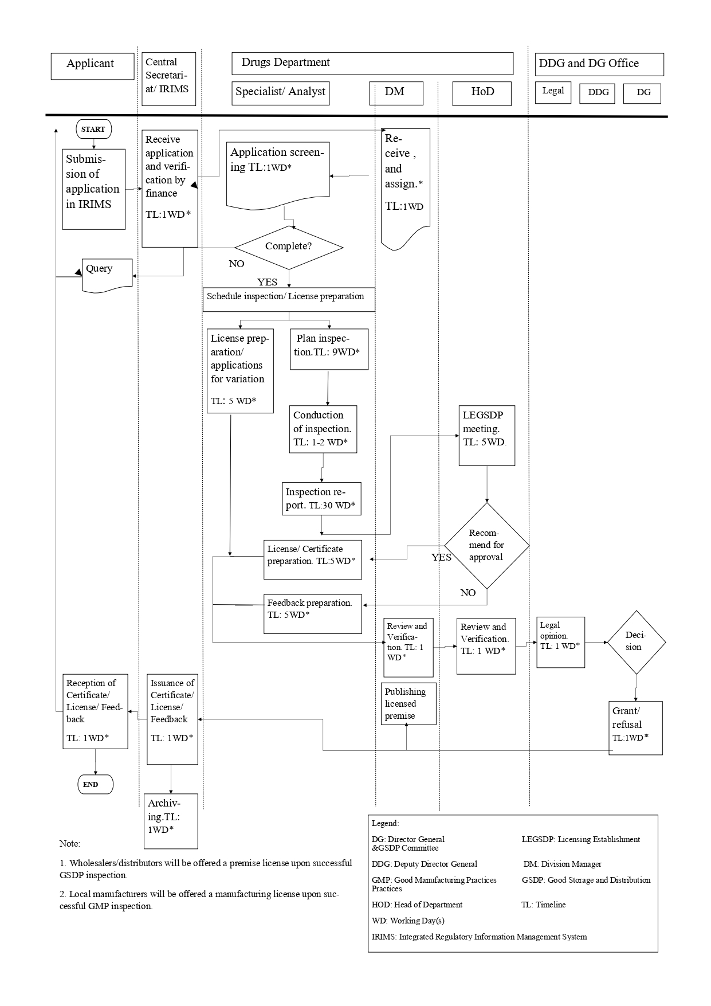

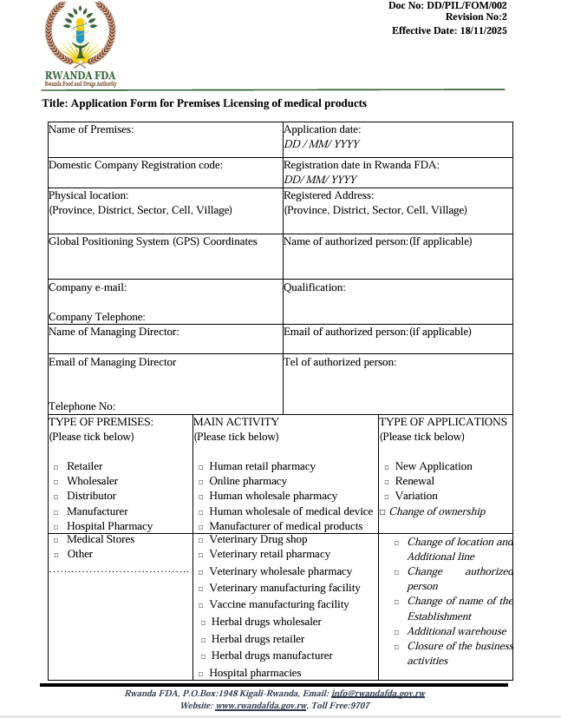
ANNEX II: APPLICATION FORM
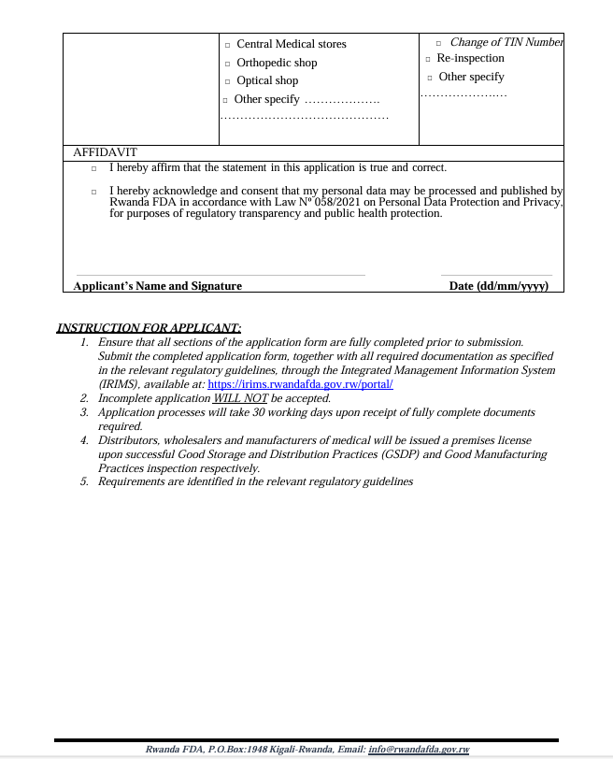

ANNEX III: PREMISES REGISTRATION CERTIFICATE

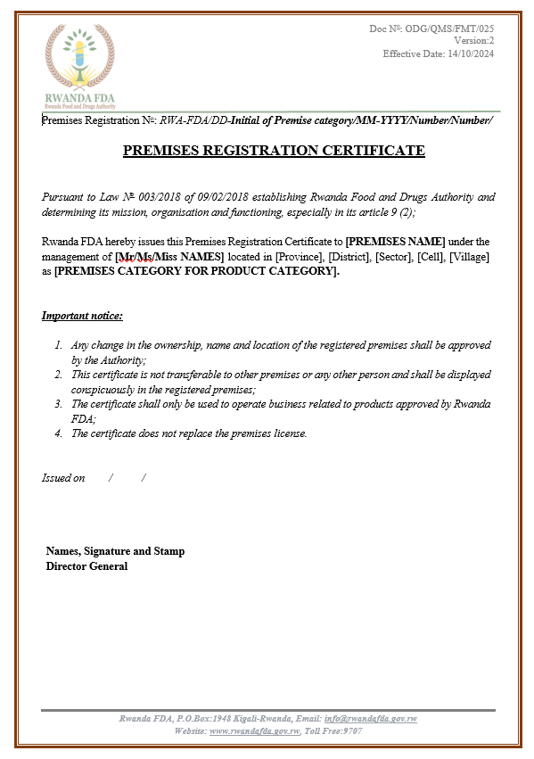

ANNEX IV: FORMAT OF AUTHORIZATION ISSUED

- PREMISES LICENSE FOR STORAGE, DISTRIBUTION, AND DISPENSING
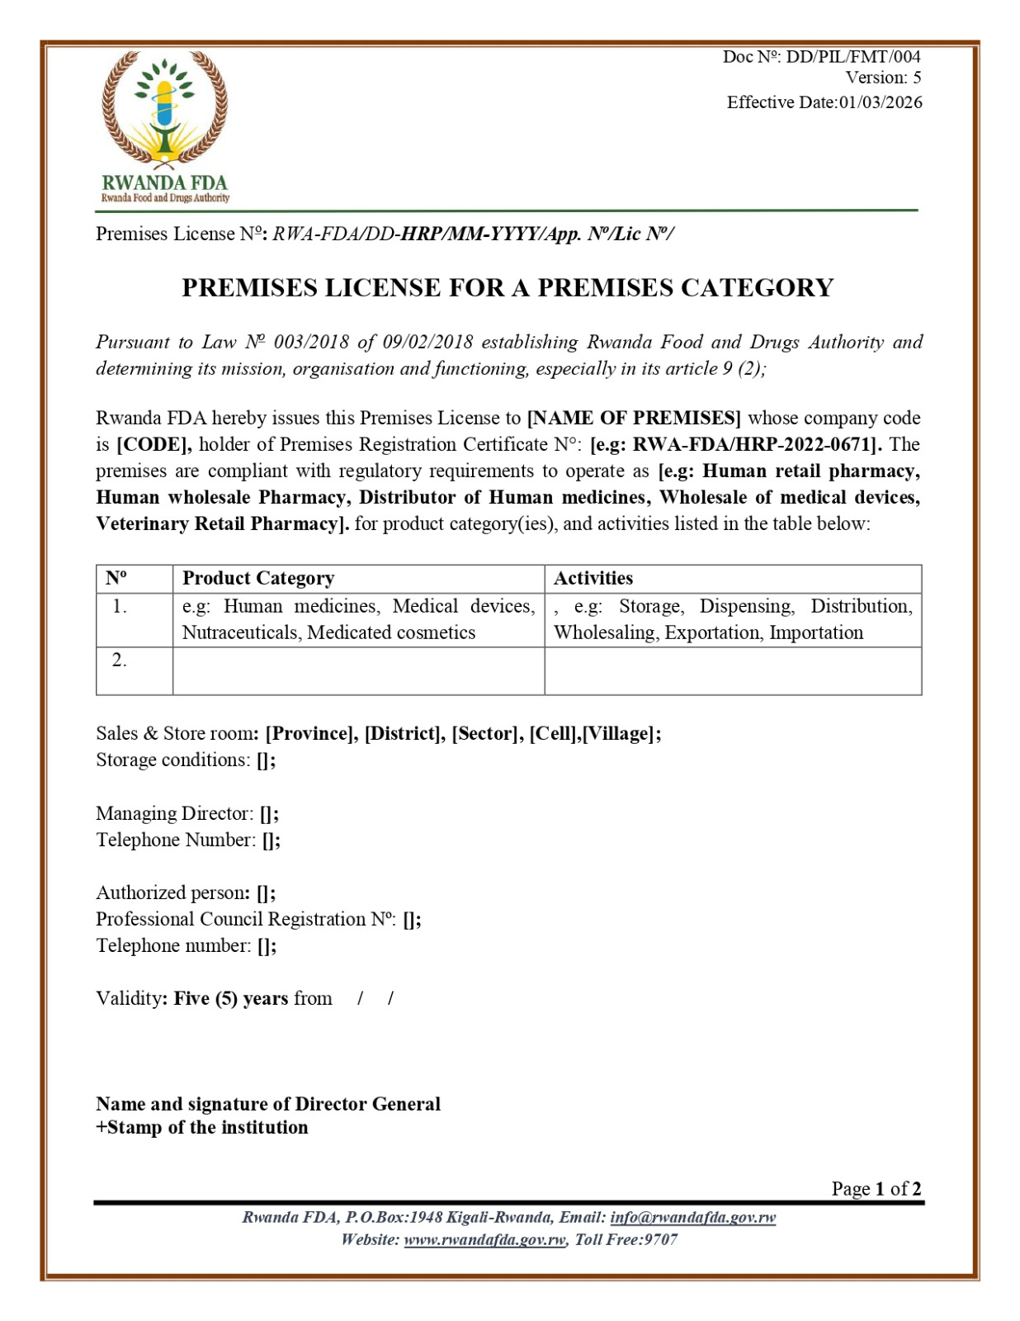

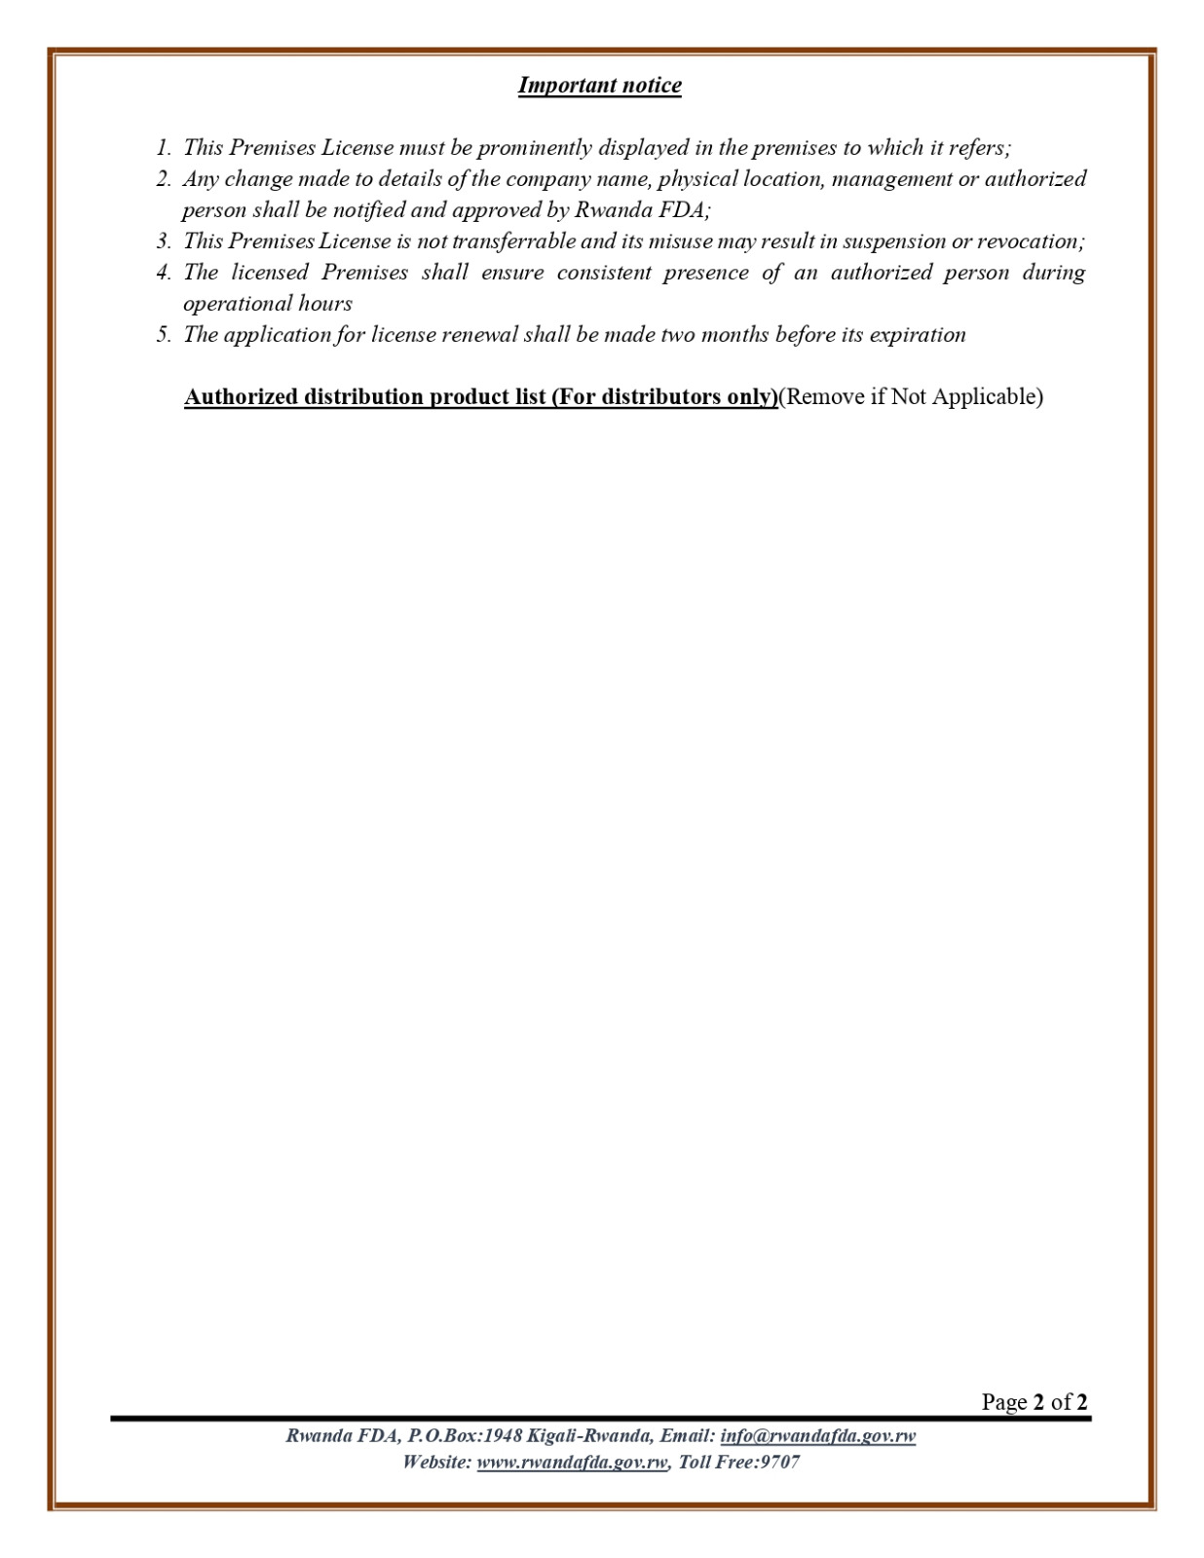

- MANUFACTURING LICENSE FOR PHARMACEUTICAL FACILITIES

